**CONTRACTOR’S OBLIGATIONS FOR WORKING AT YARA SITE IN FINLAND (YARA SUOMI IS CONSIDERED AS A CONSTRUCTION SITE)**

Safety pre-audit for contractor

Document requirements (14.1)

Before the contract

Approval for sub-contractors (14.4)

Contractor’s document obligations for working at Yara site

Document preparations,

ID-cards, safety trainings (14.2)

Before arrival at site

Data to Zeroni (documents, workers, subcontractors)

When arriving at

the site

Access keys from Main gate

14.1 Document requirements for the contract with Yara

14.2 Document preparations before arrival at Yara site

Zeroni: How to get employees the access to Yara site

Zeroni instructions

14.4 Applying Yara’s approval for Contractor's Sub-contractors

# 14.1 Document requirements for the contract with Yara

Send the following documents to your purchaser:

* Fill out safety pre-audit form
* Get approval for your subcontractors from Yara (see section 14.4)
* Documents required by Finnish Law on Construction or, if available, your Reliable Partner -report from Vastuugroup.fi
  + 1. Extracts from
    - Finnish tax prepayment register
    - register of employers
    - VAT (value-added tax) register
  + 2. Extract from register of companies (eg. Chamber of Commerce)
  + 3. Clarification of tax in due (Statement from your tax office)
  + 4. Clarification of the pension insurance premium
  + 5. Clarification of the collective agreement or the terms of employment for the contract
  + 6. Copy of the company’s accident insurance
  + 7. Copy of the Company’s Occupational health care partner
* Insurance certifications: All Contractors working at Yara Sites must have **a general liability insurance**. If the contract involves installation, the Contractor must also have **an installation liability insurance.** If the contract involves lifting, **an erection all risk general insurance** is needed. If the contract involves construction works, the Contractor must take **a construction all risk insurance** (CAR), that covers also the side- and sub-contracts. The Contractor shall therefore submit the Orderer the document a. in any case and the documents b.-d. if applicable.

1. Certificate of a general liability insurance, minimum liability 2.000.000 eur
2. Certificate of an installation liability insurance, minimum liability 2.000.000 eur
3. Certificate of an erection all risk general insurance, minimum liability 80.000 eur
4. Certificate of a construction all risk insurance (CAR), minimum liability the replacement value of the Delivery

# 14.2 Document preparations before arrival at Yara site

* Arrange a **representative for your company** and employees in Finland, who is authorized to act in a court of law for the company posting workers. The representative must have an address in Finland, and you need the contact details for employee data
* Submit your **notification of posted workers** to the Finnish Occupational Safety and Health authority in this link: [Notification of posting workers - Suomi.fi](https://www.suomi.fi/services/notification-of-posting-workers-regional-state-administrative-agency/6e76091d-1893-4f84-8f4f-ad71c8319160) . Download and save the certification of the completed notification.
* Get your employees the **Finnish tax number** and **ID-code**. Detailed instructions about Finnish tax numbers and tips how to speed up the process in this link: [The tax number - vero.fi](https://www.vero.fi/en/individuals/tax-cards-and-tax-returns/arriving_in_finland/work_in_finland/specific-instructions-for-different-occupations/coming-to-a-construction-site-or-a-shipyard/Tax_number/) . To get the Finnish ID-code, the employee must visit the tax office in person. Book a time to visit the tax office by calling the general tax service number +358 29 497 070.
* Get your employees an **employee ID-card or a document** with employee name, photo, Finnish tax number, employer name, VAT and corporate form. The document must be on person at Yara site.
* Completion of Yara gate safety trainings (create your own credentials, with the Finnish tax number) in this link: <https://yara.community.gimletlms.com/en/login>

**Zeroni: How to get employees the access (key) to site**

Your company gets a profile in Zeroni access control system. Log-in to Zeroni at this link: <https://app.zeroni.fi/> . Credentials are created to you by your local Yara purchaser. Fill out the following data into Zeroni:

1. Submit your company documents required by Finnish Law (see section 14.1) to your company profile. As soon as those documents are checked and approved in Zeroni by Yara purchaser, you can add your employee and subcontractor data. If you have an approved Reliable Partner -report available at Vastuugroup.fi, you don’t need to submit these.
2. Add your employee data with the following documentation/files:
   * Contact details
   * Finnish tax number

* Photo of employee ID card or a document with information defined in point 14.2
* Valid occupational safety card (SSG card or Finnish Green Card)
* Passport
* A1 or E101 certificate (social security certificate in EU) or certificates on Work Pension insurance and health insurance in Finland
* Work permit (only non-EU and non-EEA citizens)
* Certification of notification of posted workers (which you got in Suomi.fi link above)
* Contact details of your representative in Finland
* Duration of the job site permit

1. Add your subcontractor data:
   * Company contact details and documents, and duration of the job site permit
   * Contact person, if you want to grant your subcontractor the right to maintain their own employee data
   * Documents required by Finnish Law on Construction (see section 14.1) or, if available, your subcontractor’s Reliable Partner -report from Vastuugroup.fi. When those are approved, the employee data can be added
   * Their employee data, in the same way and with the same document requirements as described above in point 2.

Contact Zeroni helpdesk at [support@zeroni.fi](mailto:support@zeroni.fi) or your local purchaser if you need instructions.

**Zeroni instructions**

Yara uses Zeroni-system to manage access control and contractor employee data. Yara grants the Contractor’s contact person(s) the access to Zeroni-system. The contact person(s) gets an email and, when logging in, an SMS-message with a password. The contact person shall add their company data and their employees into Zeroni. Contractor also chains their subcontractors and adds subcontractor’s employees into Zeroni. Access keys are granted for employees, who are registered and qualified in Zeroni.

Please see the following instructions**:**

Log in at <https://app.zeroni.fi/login> .

To change language settings in Zeroni, choose English on the log-in screen or in your profile.

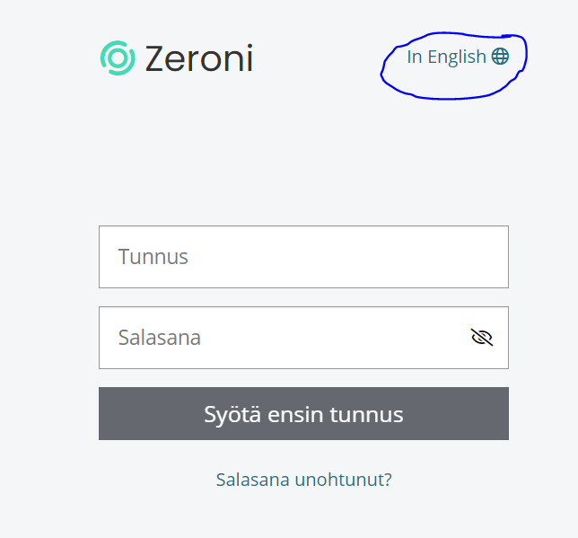

Go to “Sites” and choose the correct site. Then, add your employee data in Add persons.

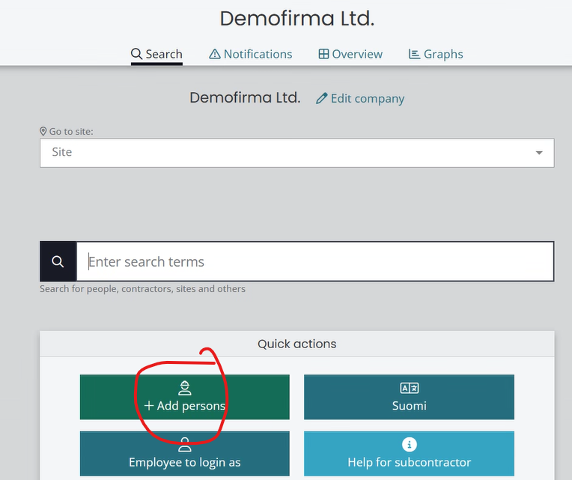

Choose your company if needed. If you can’t select your company/contract, please contact your Yara contact person.

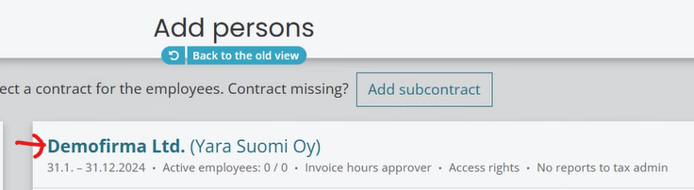

Add a new person or use existing employee data if you have.

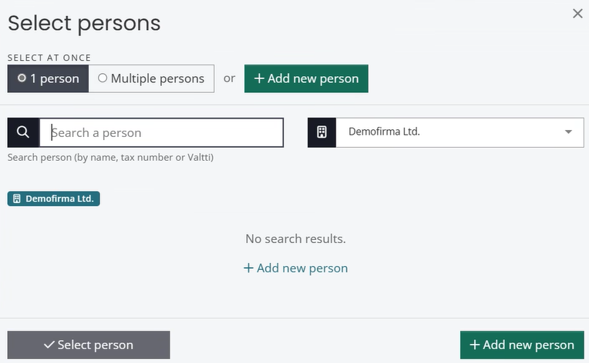

Start with the Finnish tax number.

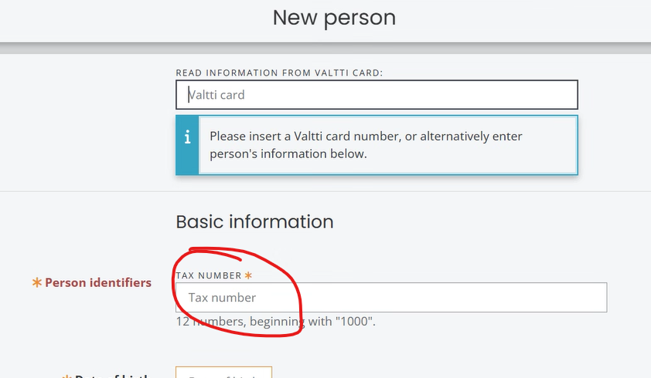

Submit the employee data, see the next 6 pictures. The requirements are defined in 14.2 (Zeroni: How to get access key…), also Zeroni gives advice about the documentation.

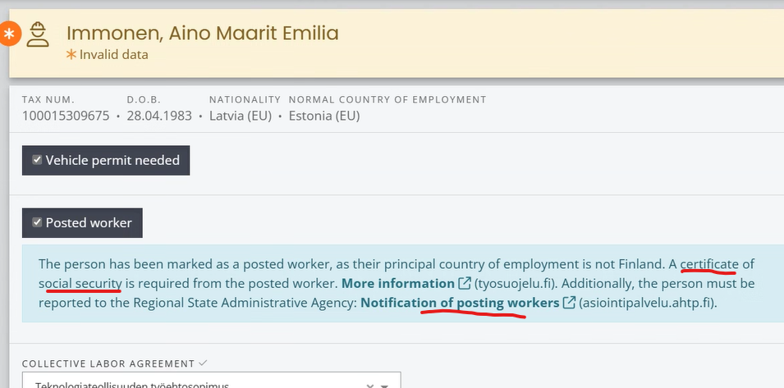

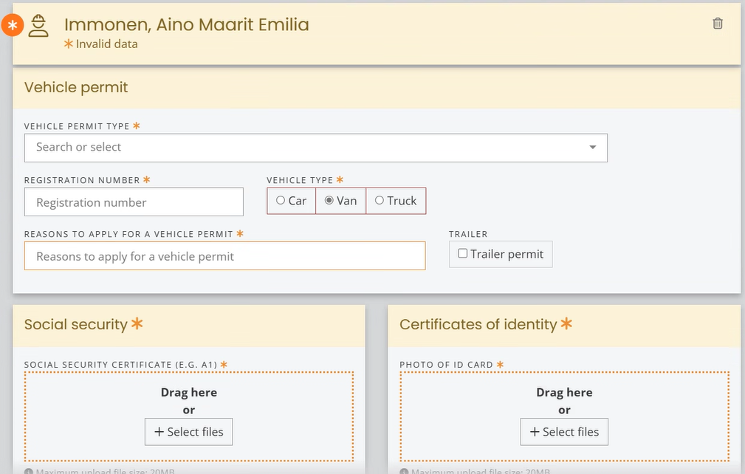

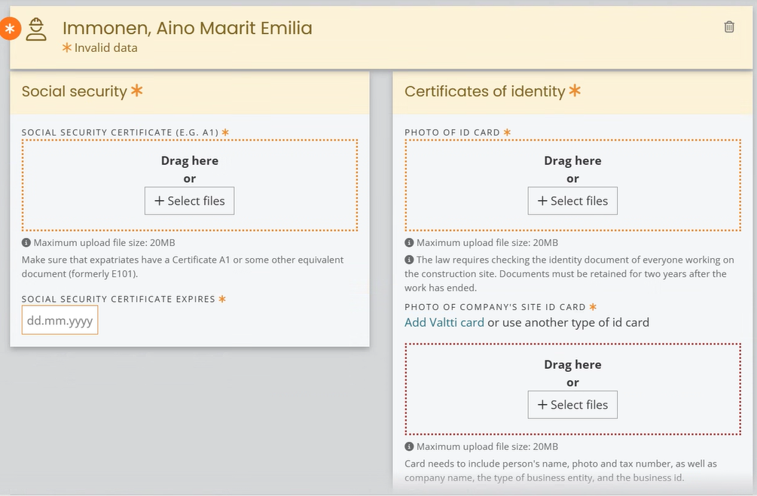

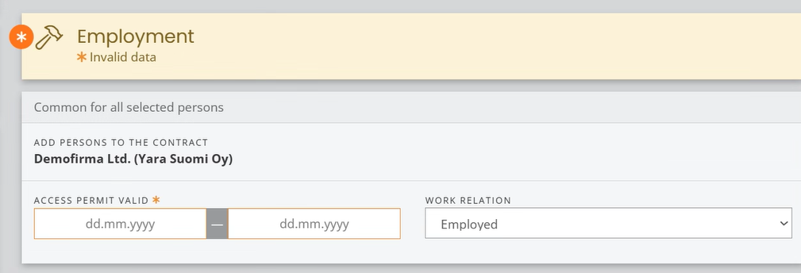

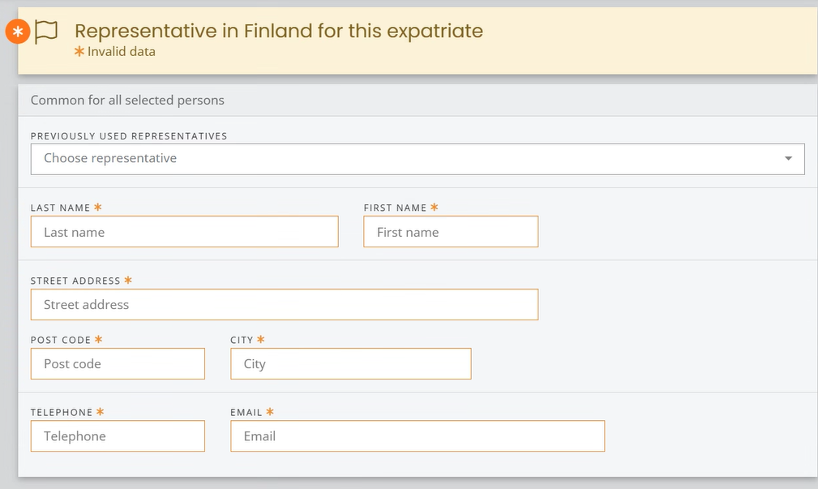

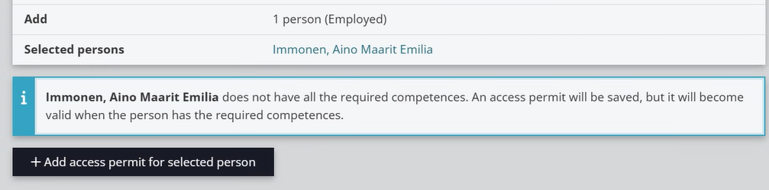

You have to get Yara’s approval for your subcontractors, use form 14.4. To add your subcontractors in Zeroni, go to “Contractors”, choose your company, click “Create subcontract” and add the subcontractor and employee data.

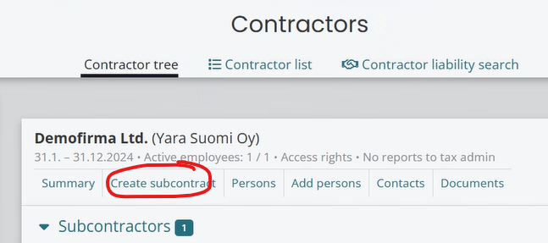

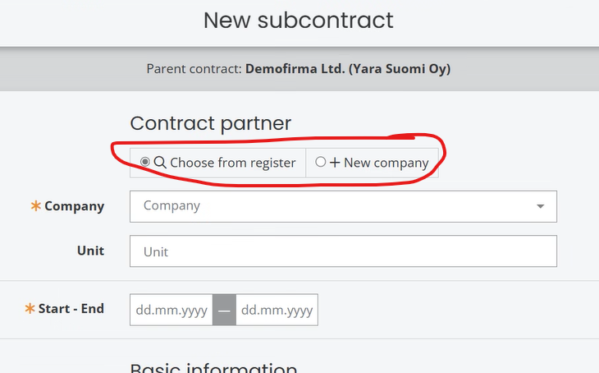

Also choose the correct Business ID type.

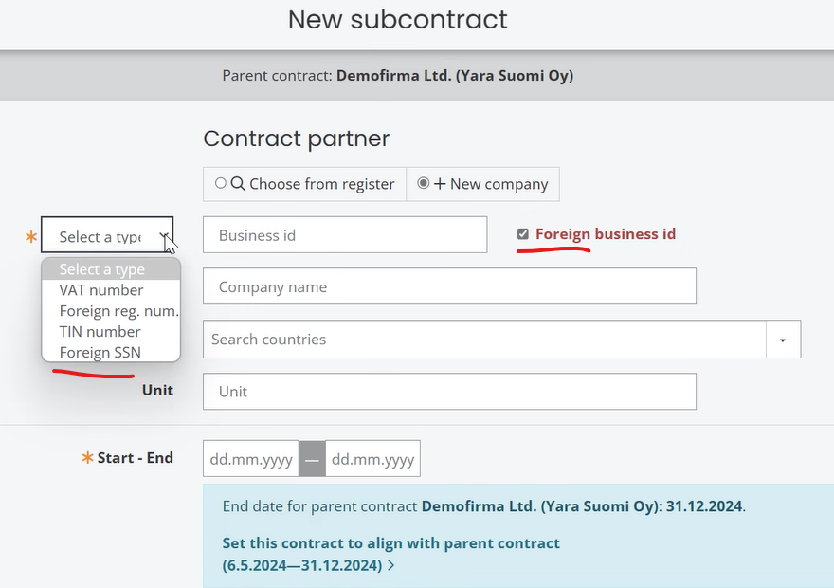

Yara’s direct contractor is in charge of their subcontractor chain. However, you can grant your subcontractor the right to maintain their own data and documents in Zeroni by filling out the data below. The phone number must be reachable by an SMS message, for log-in.

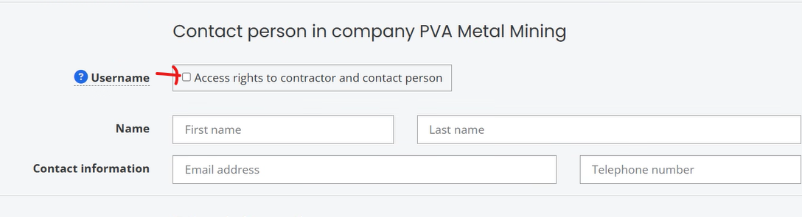

If your subcontractor is not in Trusted Partner -program (Vastuugroup.fi), submit here their company documents, defined in 14.1.

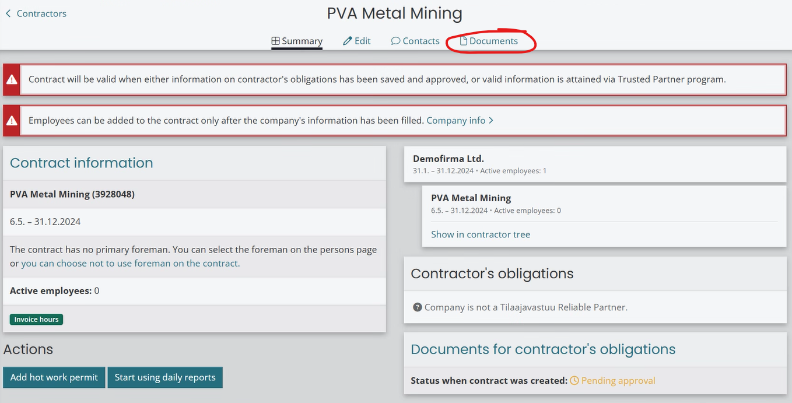

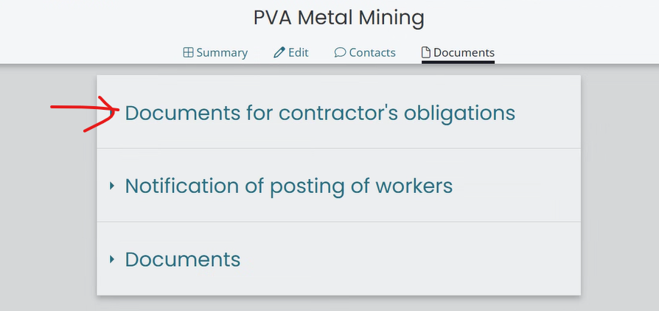

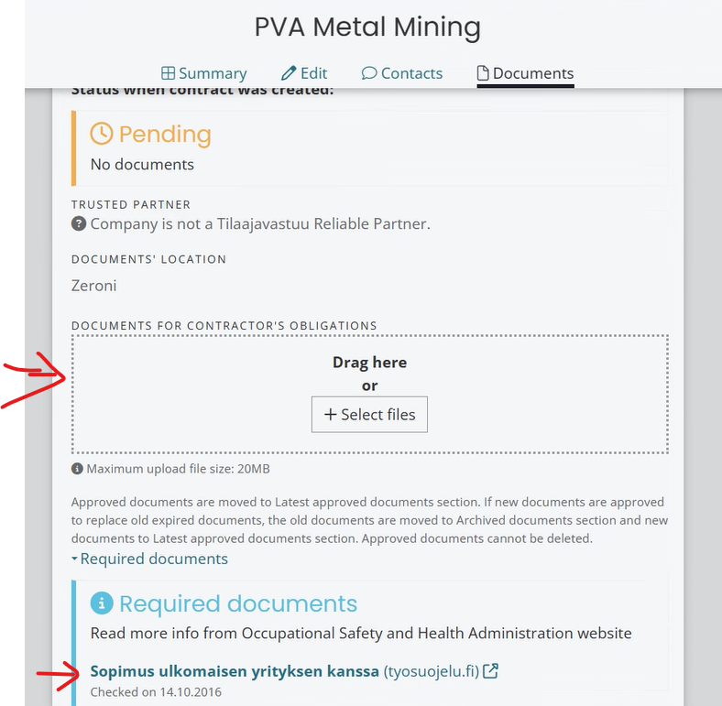

Inform Yara procurement when the documents are ready for review and approval in Zeroni. After approval, you can add the employee data.

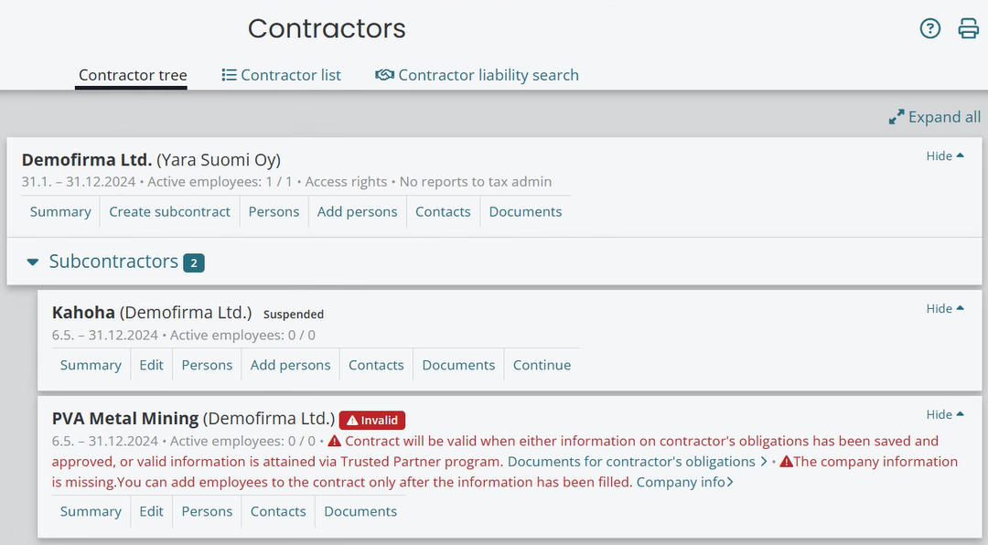

During your work at Yara site, please keep an eye on the Notifications in your own company profile. Your pending tasks are listed there.

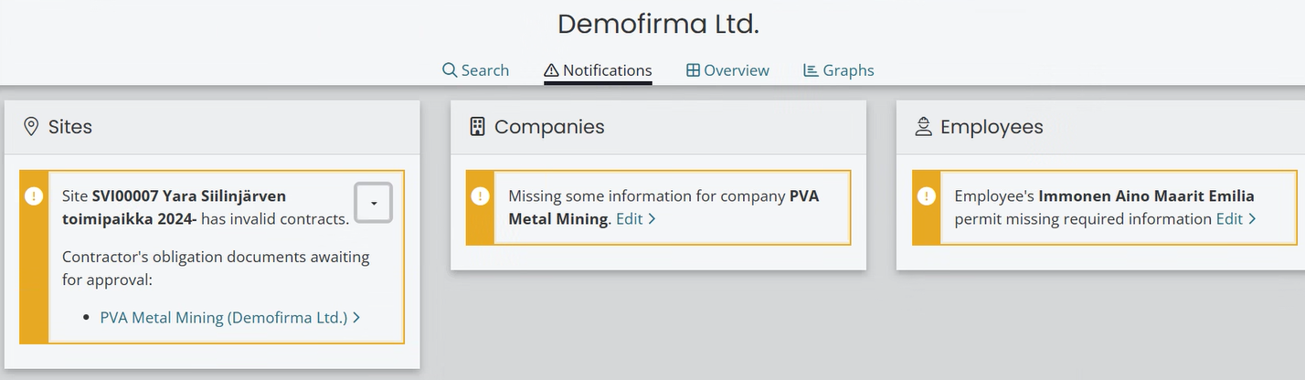

Zeroni helpdesk can be reached at [support@zeroni.fi](mailto:support@zeroni.fi) or by phone at 8-16 tel. +358 600 12929. Please see also the Support pages in low left corner in letter “i”.

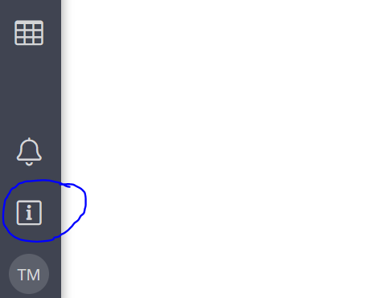

**Link to Gate Safety trainings**

The following link will get you to Gate Safety Training info:

<https://yara.community.gimletlms.com/en/login>

# ATTACHMENT 14.4 Applying Orderer’s approval for Contractor's Sub-contractors.

Contractor = A contractor in a direct contractual relation to Yara

Orderer = Yara

Sub-contractor = A contractor in a direct contractual relation to the Contractor

The Contractor shall Apply for the Yara’s approval for all sub-contractors it intends to use and before they start to work at the Site by using attachment 14.4. Any chaining of sub-contractors requires always separate negotiations with the Yara contact person. Yara Procurement grants the approvals for the Sub-contractors and maintains a register of the Sub-contractors approved.

The Contractor is responsible for filling in the Sub-contractor information in the attachment 14.4 and for submitting the signed form 14.4 to the purchasing contact person.

The Contractor shall enter the Sub-contractor’s company and employee data to Zeroni-system.

The Contractor is responsible for training the approved Sub-contractors the work safety guidelines according to the Agreement.

The Contractor is responsible for transferring contractual responsibilities and claims as applicable to Sub-contractors and ensures that the subcontractor passes on responsibilities in its own chain.

The Contractor guarantees, that it has both performed the document clearance required by the Finnish Law for this Sub-contractor and checked the Sub-contractor’s accident frequency rate and went through the Orderer’s safety requirements as for the acceptable tools, work permit processes and the risks in the work site with the Sub-Contractor.

The Contractor shall be responsible for filling this application for an approval for a Sub-Contractor, and shall file it signed to the purchasing contact person.

**ATTACHMENT 14.4 Applying Orderer’s approval for Contractor's Sub-contractors**

Contractor: [In a direct contractual relation to Orderer]

Project: [To which project is the approval being applied? Agreement or purchase order number]

**PRESENTATION OF SUB-CONTRACTOR**

**Sub-contractor:**

Who has ordered the work? [Fill if someone else than Contractor is the Orderer of the work, e.g when chaining)

Company

Address

VAT-number

Description and duration of the work

**Company presentation**

Number of employees and turnover:

References for Contractor:

Accident frequency rate for the last 3 years (LTI):

**Safety clearance**

The Contractor guarantees, that it has performed the safety clearance required for this Sub-contractor as for accident frequency rate, and assessed the use of this Sub-Contractor for the work site. The Contractor guarantees, that the Sub-Contractor has been informed of the following safety practices of the Orderer (please tick):

Gate safety induction and access control

Requirements for tools and their inspections

Work permit practices at the Orderer’s work site

Risks and controlling them at the work site

**Finnish Law**

The Contractor guarantees, that it has performed the document clearance required by the Finnish Law for this Sub-contractor, and that those documents fulfill the requirements of the Finnish Law. In addition the contractor guarantees, that it has checked the following requirements.

2 M€ liability insurance

      ______________________________________________

Date Signature